Functional annotation of proteins with comparative modelling of ERY 4 of P. Eryngii

Rambaldelli Guglielmo UniBo

1 - INTRODUCTION

The gene ERY 4 is present in the UniProt[3] database as a Laccase but it is poorly annotated, our aim is to manually annotate the protein and make it more reliable, to do it we will need to build by omology the protein.

Laccases are enzymes that belogns to the blue multicopper protein family[8], thay are able to oxidize a lot of phenolic substrate but in particular lignin.
The active site of the laccases is caracterized by four copper: one in the active site(T1) and three inside the molecule to reduce the oxygen(one T2 and two T3).
The copper are keept in place via cordiantion bond with HIS residues present in the area.

2 – METHOD

2.1 – DataBase
The known sequence has been aligned with UniProtKB[3] trought BLAST[1] (E 0.1) to find a template, The most suited one is 1 GYC.
The data regarding the template has been collected in PDB[2] and the annoation for it in UniProt[3] Q12718.

2.2 – Computational Method
Our sequence has been aligned with 1 GYC with Lalign[4] using a global alignment BLOSOM 63.
Five model has been made by omology using Modeller[5], than the hypotetical structure has been contolled with ProCheck [6] and superimposed to the template using JCE[7].
Finally the manual revision has been done using Chimera[8].

3 - TEMPLATE SELECTION

As a template has been chosen 1 GYC and wealigned the two protein with Needleman and wush algorythm using a BLOSOM 63 matrix with Lalign(FIG. 3.1) .

We chose 1 GYC as a template because of the high identity (59%) and similarity (79.7%), the fact that 1 GYC is annotated as a laccase in SwissProt[3] and so has the same type of functional site as the target suggesting the appartenence of the target to the familiy.
Moreover there is the experimentally determined crystalline structure with a resolution of 1.9 Armstrong.

The signal peptide sequence was removed from the target in order to adapt it t the template.

The coverage is 98% as we can see from the alignment the target is 15 residues longer than the template, this part has been removed during the modelling.

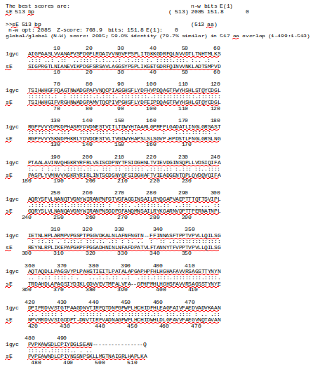
FIG. 3.1: Sequence alignment
of the template (1 GYC) and the target protein without the signal peptide.

4 – MODELLER

Starting from the alignment we created a PIR file using a bash script and then we modified a few thing:
1-PIR file: Added copper atoms to the alignment.
2-PIR file: Removed last 15 residues from the target in the alignment because the coverage of the template wasn't enought to model them.
3-PDB file: Modified the PDB file to incorporate the copper atom.

Then we executed Modeller trought a Python script producing five different model(FIG. 4.1) and from the internal validation of modeller model 2 seems the best one.

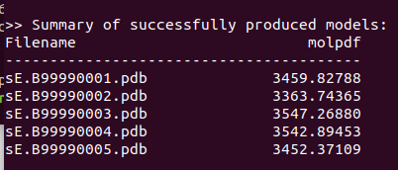

FIG. 4.1: Molpdf of the five model generated.

5 - PROCHECK
The created models has been check with procheck to analyze the dihedral angle and the resulting stability.

1-MODEL
Ramachandran plot: 91.2% core 8.3% allow 0.2% gener 0.2% disall

2-MODEL
Ramachandran plot: 90.2% core 9.3% allow 0.5% gener 0.0% disall

3-MODEL
Ramachandran plot: 90.5% core 8.5% allow 1.0% gener 0.0% disall

4-MODEL
Ramachandran plot: 89.8% core 9.5% allow 0.7% gener 0.0% disall

5-MODEL
Ramachandran plot: 90.2% core 9.5% allow 0.1% gener 0.1% disall

In the end Model 2 was chosen because of the lower modeller score indicating a lesser RMSD to the template and of the best fit in the Ramachandra plot leaving the least residue in unfavorable conformation .

The Ramachandran plot show us a good folding, the few residues incompatible with the folding are not in the active site and the majority of the others are compatible with the structure meaning the the protein will have a good stability.

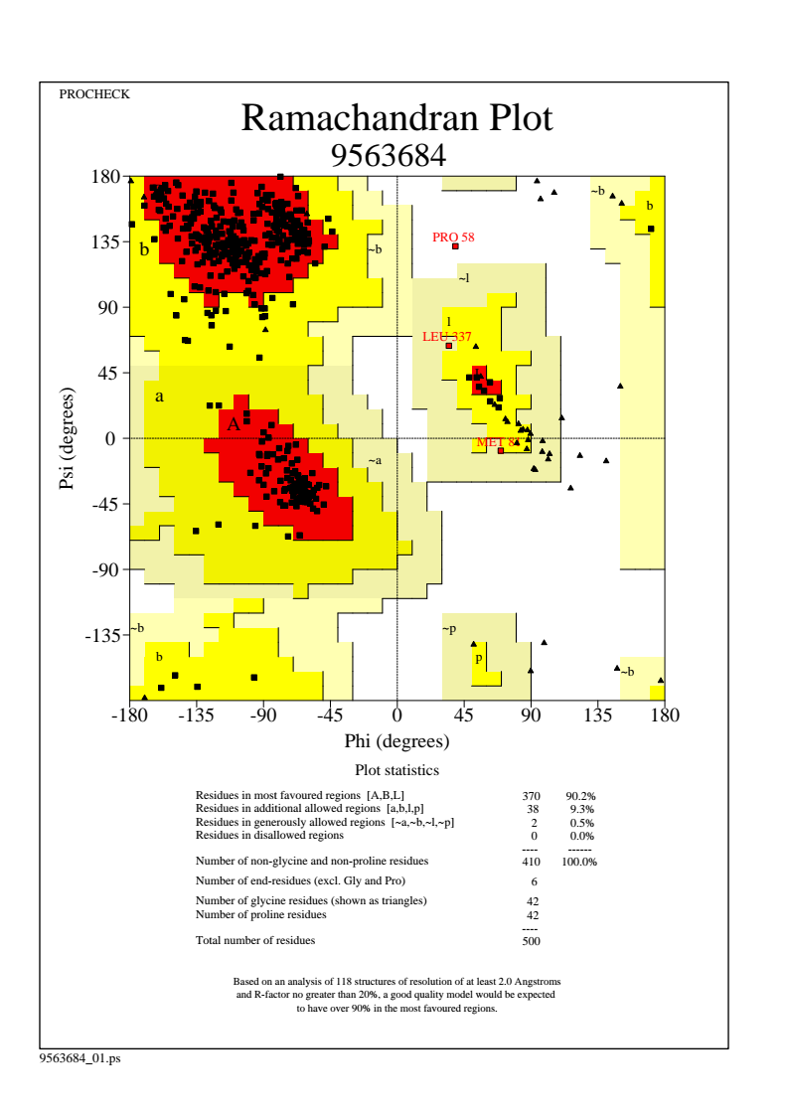

6 - TARGET ANNOTATION

JCE was used to superimpose the model to te template, we obteained a RSMD of 0.26 Armstrong with identity (59%) and similarity (79.7%) suggesting functional similarity.

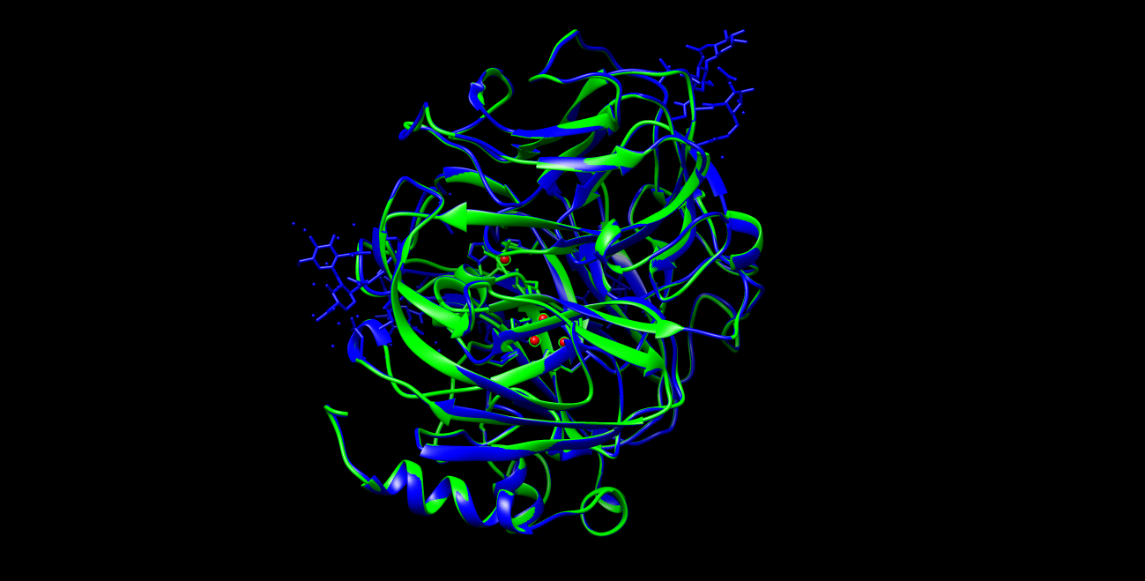
FIG. 6.1: Complete structure superimposition

6.1 – RELATIVE DISTANCE

We check if structure of the active site was conserved and measured the relative distances of the copper:
The T1 copper is the only one not perfectly superimposed (0.313 Å) while the other three have really good variation (0,034Å 0,03Å 0,037Å)

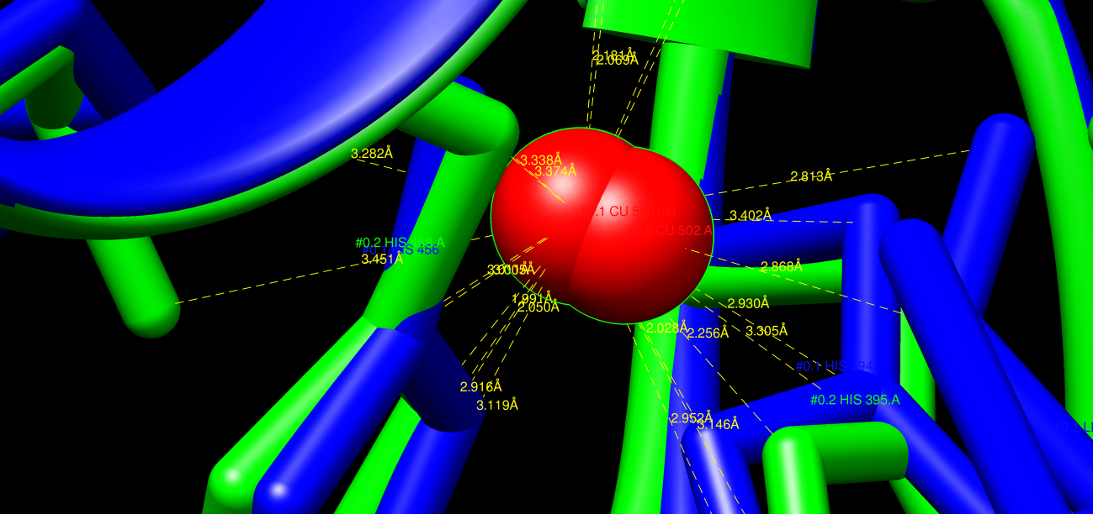
FIG. 6.2: Copper T1 in the active site.

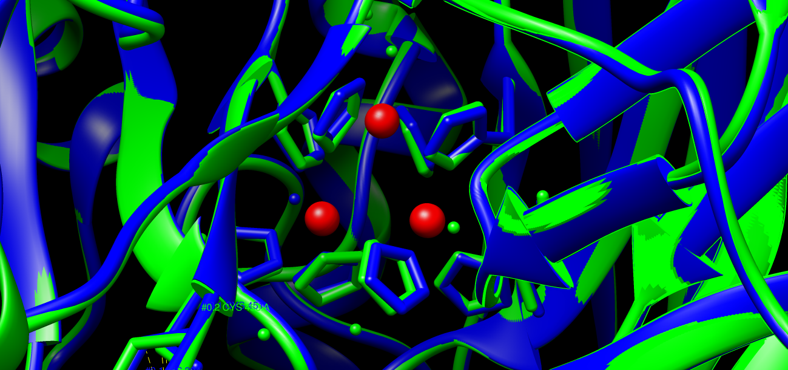
FIG. 6.3: Copper T2 and T3s in the canter of the molecule.

6.2 - DISULFITE BONDS
The disulfite bonds are conserved:

Template | Target
CYS 117-205 | CYS 117-204
CYS 488-85 | CYS 486-85

6.3 – GLYCOSYLATION
22 of the 28 Asparagine are conserved unless the ones in position:140, 331, 333, 336, 418, 497.

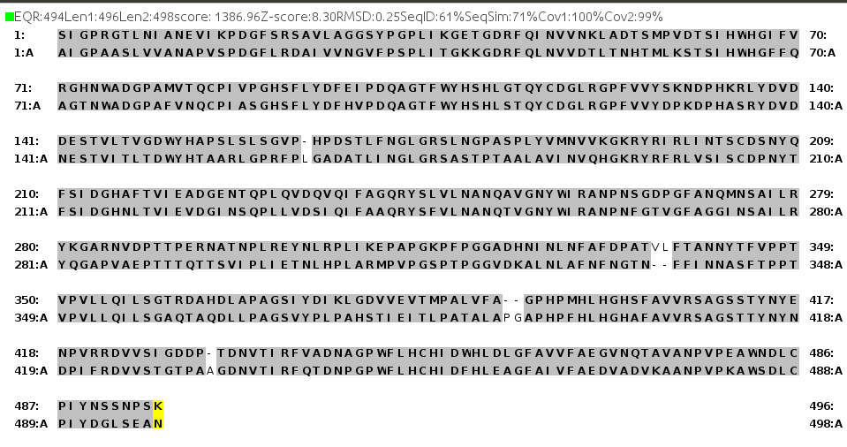
As we can see the sequence after the superimposition fit really well the template:
So we can say that our proteine is definitly a Laccase and we can also say that the active site have the same structure and functionality.

7 - FUNCTIONAL ANNOTATION

From the result of the omology modelling we can say that the active site is conseved and so our target is a laccase.
So we can transfer the GO annotation from the template to it.

GO:0005507  copper ion binding | ECO:0000256  IEA | GO_REF:0000002 | InterPro:IPR011706 more... | 5325 Trametes versicolor
GO:0016491  oxidoreductase activity | ECO:0000256  IEA | GO_REF:0000002 | InterPro:IPR011706 | 5325 Trametes versicolor
GO:0016491  oxidoreductase activity | ECO:0000322  IEA | GO_REF:0000037 | UniProtKB-KW:KW-0560 | 5325 Trametes versicolor
GO:0046872  metal ion binding | ECO:0000322  IEA | GO_REF:0000037 | UniProtKB-KW:KW-0479 | 5325 Trametes versicolor
GO:0052716  hydroquinone:oxygen oxidoreductase activity | ECO:0000501  IEA | GO_REF:0000003 | EC:1.10.3.2 | 5325 Trametes versicolor
GO:0046274  lignin catabolic process | ECO:0000322  IEA | GO_REF:0000037 | UniProtKB-KW:KW-0439 | 5325 Trametes versicolor
GO:0055114  oxidation-reduction process | ECO:0000256  IEA | GO_REF:0000002 | InterPro:IPR001117 more... | 5325 Trametes versicolor
GO:0055114  oxidation-reduction process | ECO:0000322  IEA | GO_REF:0000037 | UniProtKB-KW:KW-0560 | 5325 Trametes versicolor
GO:0005576  extracellular region | ECO:0000322  IEA | GO_REF:0000037 | UniProtKB-KW:KW-0964 | 5325 Trametes versicolor
GO:0005576  extracellular region | ECO:0000322  IEA | GO_REF:0000039 | UniProtKB-SubCell:SL-0243 | 5325 Trametes versicolor

8 – RESULTS AND DISCUSSION

In the end we can say that our protein belongs to the Laccase family because the active site is well conserved and the atoms necessary for the catalitic activity are present(Cu).
Moreover the taget protein have a longer N-terminal tail but it dose not belong to the functional region of the protein and should not interfere with the activity.

9 - REFERENCE

[1] BLAST at NCBI
Paper: PMID: 2231712
Release: 2.8.1: December 13, 2018
Link: https://blast.ncbi.nlm.nih.gov/Blast.cgi

[2] RCSB PDB
Authors: H.M. Berman, J. Westbrook, Z. Feng, G. Gilliland, T.N. Bhat, H. Weissig, I.N. Shindyalov, P.E. Bourne.
Paper: The Protein Data Bank Nucleic Acids Research, 28: 235-242.
Release: February 2016
Link: https://www.rcsb.org/

[3] UniProt
Paper: UniProt: the universal protein knowledgebase Nucleic Acids Res. 45: D158-D169 (2017)
Release: 2018_11 (05-Dec-2018)
Link: https://www.uniprot.org/

[4] Lalign
Author: William Pearson
The lalign program implements the algorithm of Huang and Miller, published in Adv. Appl. Math. (1991) 12:337-357.
Link: https://embnet.vital-it.ch/software/LALIGN_form.html

[5] Modeller
Author: Andrej Sali
Paper: A. Sali & T.L. Blundell. Comparative protein modelling by satisfaction of spatial restraints. J. Mol. Biol. 234, 779-815, 1993.
Release: 9.21, which was released on Dec 11th, 2018
Link: https://salilab.org/modeller/

[6] ProCheck at EMBL-EBI
Authors: Laskowski R A, MacArthur M W, Moss D S & Thornton J M (1993).
Paper: PROCHECK: a program to check the stereochemical quality of protein structures. J. Appl. Cryst., 26, 283-291.
Link: https://www.ebi.ac.uk/thornton-srv/software/PROCHECK/

[7] UCSF Chimera
Authors: Pettersen EF, Goddard TD, Huang CC, Couch GS, Greenblatt DM, Meng EC, Ferrin TE. J Comput Chem. 2004 Oct;25(13):1605-12.
Paper: UCSF Chimera--a visualization system for exploratory research and analysis.
Release: 1.13.1 17 november 2018
Link: https://www.cgl.ucsf.edu/chimera/

[8]Crystal Structure of a Laccase from the Fungus Trametes versicolor at 1.90-Å Resolution Containing a Full Complement of Coppers*
Author:Klaus Piontek‡, Matteo Antorini§, and Thomas Choinowski
Affiliation: From the Institute of Biochemistry, Swiss Federal Institute of Technology (ETH), ETH-Hönggerberg, Building HPM, Room D 8.1-2, CH-8093 Zürich, Switzerland

